

**BLG 372E**

**ANALYSIS OF ALGORITHMS II**

CRN: 22853

**REPORT OF HOMEWORK #1**

Submission Date: 18.03.2014

**STUDENT NAME: TUĞRUL YATAĞAN**

**STUDENT NUMBER: 040100117**

# **Introduction**

In this project, we implement a lecturer-assistant assignment problem. Lecturers have preference lists for assistants. Assistants have preference list for the courses. One lecturer can have more than one course in the term. However an assistant can have only one course in each term.

# **Development and Operating Environments**

Eclipse for C++ integrated development environment has been used to write the source code in Ubuntu 12.04 operation system and GNU g++ compiler has been used for compiling under Ubuntu 12.04 operation system.

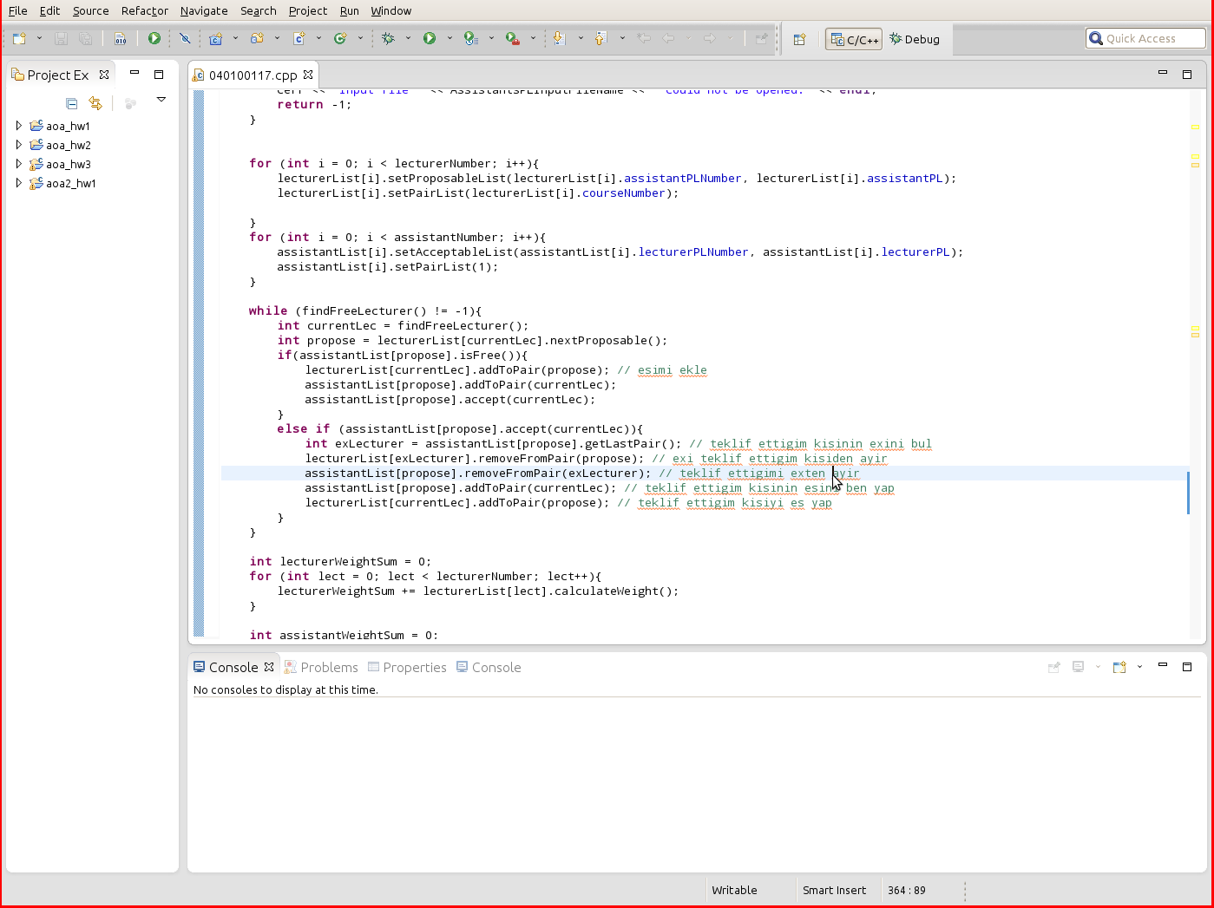

The program built and compiled without any warning or error under g++ and the program executed with commands:

g++ 040100117.cpp –o GS

./GS –i CourseOfLecturers.txt LecturersPL.txt AssistantsPL.txt –o GS_out.txt

Sample output is below:

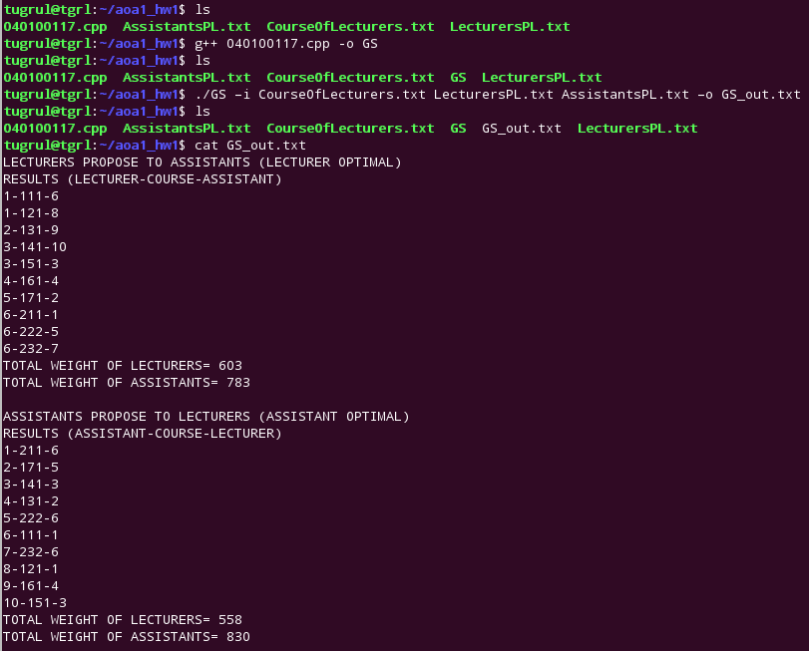

# **Data Structures and Variables**

A main Matching class is inherited from both Lecturer and Assistant class for Gale-Shapley algorithm. Lecturer and Assistant classes has specific attributes and variables for their purposes.

class Matching{ // base class for propose-reject algorithm

int *proposable; // list of member who candidate for propose

int *acceptable; // list of member who candidate for acceptance

int currentPairNumber; // current number of pair

int maxProposableNumber; // maximum number of propose list

int maxPairNumber; // maximum number of pair list

protected:

int maxAcceptanceNumber; // maximum number of acceptance list

public:

int *pair; // pair list

void setProposableList(int, int *); // initialization for proposable list

void setPairList(int); // initialization for pair list

void setAcceptableList(int, int *); // initialization for acceptance list

int nextProposable(); // calculates next element suitable for propose

void addToPair(int); // adds to pair list

void removeFromPair(int); // removes pair list

int getLastPair(); // returns pair

int multiGetLastPair(); // return last pair for list

bool accept(int); // checks if propose is acceptable

bool multiAccept(int); // checks if propose is acceptable for list

bool isFull(); // is pair list full

bool isFree(); // is pair list empty

Matching(); // default constructor

};

class Lecturer: public Matching { // lecturer class inherited from matching

public:

int courseNumber;

int assistantPLNumber;

int *courses; // course list

int *assistantPL; // assistant preference list

void addCourses(int, int *); // initialization for course list

void addAssistantPL(int, int *); // initialization for assistant pref. list

bool searchCourse(int); // searches course

int calculateWeight(); // calculates weight for lecturer

};

class Assistant: public Matching {

public:

int coursePLNumber;

int lecturerPLNumber;

int *coursePL; // course preference list

int *lecturerPL; // lecturer preference list

void addCoursePL(int, int *); // initialization for course list

void addLecturerPL(int, int *); // initialization for lecturer list

int findInLecturerPL(int); // searches lecturer

int calculateWeight(); // calculates weight for lecturer

};

# **Analysis**

Main matching algorithm is:

while (findFreeLecturer() != -1){ // bosta hoca var mı

int currentLec = findFreeLecturer(); // bos hoca ata

int propose = lecturerList[currentLec].nextProposable();

// teklif edilebilecek kisi bul

if(assistantList[propose].isFree()){ // teklif ettigim bos mu

lecturerList[currentLec].addToPair(propose); // esi ekle

assistantList[propose].addToPair(currentLec); // esimi bana ekle

assistantList[propose].accept(currentLec); // esim beni kabul etsin

}

else if (assistantList[propose].accept(currentLec)){

// teklif ettigim beni tercih ediyor mu

int exLecturer = assistantList[propose].getLastPair();

// teklif ettigim kisinin eski esini bul

lecturerList[exLecturer].removeFromPair(propose);

// eski esi teklif ettigim kisiden ayir

assistantList[propose].removeFromPair(exLecturer);

// teklif ettigimi eski sevgiliden ayir

assistantList[propose].addToPair(currentLec);

// teklif ettigim kisinin esini ben yap

lecturerList[currentLec].addToPair(propose);

// teklif ettigim kisiyi benim esim yap

}

}

Algorithm above is implementation of this propose and reject algorithm pseudo code:

while ∃ free man m who still has a woman w to propose to {

w = m's highest ranked woman to whom he has not yet proposed to

if w is free

(m, w) become engaged

else some pair (m', w) already exists

if w prefers m to m'

(m, w) become engaged

m' becomes free

}

}

Complexity of the algorithm mainly relates on while loop. So length of the maximum preference list determinative for complexity.

Length of the preference list for assistants and lecturers is = n

Complexity is O(n2)

# **Conclusion**

During this homework, I have become more familiar with the concept of matching algorithms and analysis of the algorithms. I had the chance to intensify my knowledge about instructing good and efficient algorithms.

Illustration of matching algorithm with tables:

|  |  |  |  |  |  |  |  |  |  |  |  |  |
| --- | --- | --- | --- | --- | --- | --- | --- | --- | --- | --- | --- | --- |
|  | Lecturers Assistant Preference List | | | | | | | | | |  | Course Number |
| **1)** | **10** | 8 | 6 | 4 | 3 | 2 | 1 | 9 | 7 | 5 |  | 2 |
| **2)** | 7 | 1 | 3 | 6 | 10 | 5 | 9 | 2 | 4 | 8 |  | 1 |
| **3)** | 10 | 7 | 6 | 4 | 5 | 1 | 3 | 8 | 9 | 2 |  | 2 |
| **4)** | 10 | 7 | 6 | 4 | 1 | 5 | 9 | 8 | 3 | 2 |  | 1 |
| **5)** | 7 | 3 | 2 | 4 | 5 | 9 | 8 | 1 | 6 | 10 |  | 1 |
| **6)** | 1 | 4 | 5 | 7 | 10 | 8 | 9 | 3 | 2 | 6 |  | 3 |

|  |  |  |  |  |  |  |  |  |  |  |
| --- | --- | --- | --- | --- | --- | --- | --- | --- | --- | --- |
|  | Assistants Lecturer Preference List | | | | | | | | | |
| **1)** | 6 | 4 | 3 | 5 | 3 | 6 | 2 | 6 | 1 | 1 |
| **2)** | 5 | 6 | 3 | 3 | 2 | 1 | 6 | 1 | 4 | 6 |
| **3)** | 3 | 5 | 6 | 6 | 4 | 1 | 1 | 6 | 2 | 3 |
| **4)** | 2 | 1 | 4 | 6 | 3 | 3 | 6 | 1 | 6 | 5 |
| **5)** | 6 | 6 | 3 | 4 | 2 | 5 | 1 | 3 | 6 | 1 |
| **6)** | 1 | 6 | 5 | 1 | 3 | 2 | 4 | 6 | 6 | 3 |
| **7)** | 1 | 6 | 1 | 5 | 2 | 3 | 6 | 4 | 3 | 6 |
| **8)** | 5 | 6 | 1 | 1 | 3 | 2 | 4 | 6 | 3 | 6 |
| **9)** | 6 | 3 | 6 | 5 | 4 | 2 | 6 | 3 | 1 | 1 |
| **10)** | 6 | 6 | 6 | 3 | 5 | 4 | **1** | 2 | 1 | 3 |

|  |  |  |  |  |  |  |  |  |  |  |  |  |
| --- | --- | --- | --- | --- | --- | --- | --- | --- | --- | --- | --- | --- |
|  | Lecturers Assistant Preference List | | | | | | | | | |  | C.N. |
| **1)** | **10** | **8** | 6 | 4 | 3 | 2 | 1 | 9 | 7 | 5 |  | 2 |
| **2)** | 7 | 1 | 3 | 6 | 10 | 5 | 9 | 2 | 4 | 8 |  | 1 |
| **3)** | 10 | 7 | 6 | 4 | 5 | 1 | 3 | 8 | 9 | 2 |  | 2 |
| **4)** | 10 | 7 | 6 | 4 | 1 | 5 | 9 | 8 | 3 | 2 |  | 1 |
| **5)** | 7 | 3 | 2 | 4 | 5 | 9 | 8 | 1 | 6 | 10 |  | 1 |
| **6)** | 1 | 4 | 5 | 7 | 10 | 8 | 9 | 3 | 2 | 6 |  | 3 |

|  |  |  |  |  |  |  |  |  |  |  |
| --- | --- | --- | --- | --- | --- | --- | --- | --- | --- | --- |
|  | Assistants Lecturer Preference List | | | | | | | | | |
| **1)** | 6 | 4 | 3 | 5 | 3 | 6 | 2 | 6 | 1 | 1 |
| **2)** | 5 | 6 | 3 | 3 | 2 | 1 | 6 | 1 | 4 | 6 |
| **3)** | 3 | 5 | 6 | 6 | 4 | 1 | 1 | 6 | 2 | 3 |
| **4)** | 2 | 1 | 4 | 6 | 3 | 3 | 6 | 1 | 6 | 5 |
| **5)** | 6 | 6 | 3 | 4 | 2 | 5 | 1 | 3 | 6 | 1 |
| **6)** | 1 | 6 | 5 | 1 | 3 | 2 | 4 | 6 | 6 | 3 |
| **7)** | 1 | 6 | 1 | 5 | 2 | 3 | 6 | 4 | 3 | 6 |
| **8)** | 5 | 6 | **1** | 1 | 3 | 2 | 4 | 6 | 3 | 6 |
| **9)** | 6 | 3 | 6 | 5 | 4 | 2 | 6 | 3 | 1 | 1 |
| **10)** | 6 | 6 | 6 | 3 | 5 | 4 | **1** | 2 | 1 | 3 |

|  |  |  |  |  |  |  |  |  |  |  |  |  |
| --- | --- | --- | --- | --- | --- | --- | --- | --- | --- | --- | --- | --- |
|  | Lecturers Assistant Preference List | | | | | | | | | |  | C.N. |
| **1)** | **10** | **8** | 6 | 4 | 3 | 2 | 1 | 9 | 7 | 5 |  | 2 |
| **2)** | **7** | 1 | 3 | 6 | 10 | 5 | 9 | 2 | 4 | 8 |  | 1 |
| **3)** | 10 | 7 | 6 | 4 | 5 | 1 | 3 | 8 | 9 | 2 |  | 2 |
| **4)** | 10 | 7 | 6 | 4 | 1 | 5 | 9 | 8 | 3 | 2 |  | 1 |
| **5)** | 7 | 3 | 2 | 4 | 5 | 9 | 8 | 1 | 6 | 10 |  | 1 |
| **6)** | 1 | 4 | 5 | 7 | 10 | 8 | 9 | 3 | 2 | 6 |  | 3 |

|  |  |  |  |  |  |  |  |  |  |  |
| --- | --- | --- | --- | --- | --- | --- | --- | --- | --- | --- |
|  | Assistants Lecturer Preference List | | | | | | | | | |
| **1)** | 6 | 4 | 3 | 5 | 3 | 6 | 2 | 6 | 1 | 1 |
| **2)** | 5 | 6 | 3 | 3 | 2 | 1 | 6 | 1 | 4 | 6 |
| **3)** | 3 | 5 | 6 | 6 | 4 | 1 | 1 | 6 | 2 | 3 |
| **4)** | 2 | 1 | 4 | 6 | 3 | 3 | 6 | 1 | 6 | 5 |
| **5)** | 6 | 6 | 3 | 4 | 2 | 5 | 1 | 3 | 6 | 1 |
| **6)** | 1 | 6 | 5 | 1 | 3 | 2 | 4 | 6 | 6 | 3 |
| **7)** | 1 | 6 | 1 | 5 | **2** | 3 | 6 | 4 | 3 | 6 |
| **8)** | 5 | 6 | **1** | 1 | 3 | 2 | 4 | 6 | 3 | 6 |
| **9)** | 6 | 3 | 6 | 5 | 4 | 2 | 6 | 3 | 1 | 1 |
| **10)** | 6 | 6 | 6 | 3 | 5 | 4 | **1** | 2 | 1 | 3 |

|  |  |  |  |  |  |  |  |  |  |  |  |  |
| --- | --- | --- | --- | --- | --- | --- | --- | --- | --- | --- | --- | --- |
|  | Lecturers Assistant Preference List | | | | | | | | | |  | C.N. |
| **1)** | **10** | **8** | 6 | 4 | 3 | 2 | 1 | 9 | 7 | 5 |  | 2 |
| **2)** | **7** | 1 | 3 | 6 | 10 | 5 | 9 | 2 | 4 | 8 |  | 1 |
| **3)** | **10** | 7 | 6 | 4 | 5 | 1 | 3 | 8 | 9 | 2 |  | 2 |
| **4)** | 10 | 7 | 6 | 4 | 1 | 5 | 9 | 8 | 3 | 2 |  | 1 |
| **5)** | 7 | 3 | 2 | 4 | 5 | 9 | 8 | 1 | 6 | 10 |  | 1 |
| **6)** | 1 | 4 | 5 | 7 | 10 | 8 | 9 | 3 | 2 | 6 |  | 3 |

|  |  |  |  |  |  |  |  |  |  |  |
| --- | --- | --- | --- | --- | --- | --- | --- | --- | --- | --- |
|  | Assistants Lecturer Preference List | | | | | | | | | |
| **1)** | 6 | 4 | 3 | 5 | 3 | 6 | 2 | 6 | 1 | 1 |
| **2)** | 5 | 6 | 3 | 3 | 2 | 1 | 6 | 1 | 4 | 6 |
| **3)** | 3 | 5 | 6 | 6 | 4 | 1 | 1 | 6 | 2 | 3 |
| **4)** | 2 | 1 | 4 | 6 | 3 | 3 | 6 | 1 | 6 | 5 |
| **5)** | 6 | 6 | 3 | 4 | 2 | 5 | 1 | 3 | 6 | 1 |
| **6)** | 1 | 6 | 5 | 1 | 3 | 2 | 4 | 6 | 6 | 3 |
| **7)** | 1 | 6 | 1 | 5 | **2** | 3 | 6 | 4 | 3 | 6 |
| **8)** | 5 | 6 | **1** | 1 | 3 | 2 | 4 | 6 | 3 | 6 |
| **9)** | 6 | 3 | 6 | 5 | 4 | 2 | 6 | 3 | 1 | 1 |
| **10)** | 6 | 6 | 6 | **3** | 5 | 4 | **1** | 2 | 1 | 3 |

|  |  |  |  |  |  |  |  |  |  |  |  |  |
| --- | --- | --- | --- | --- | --- | --- | --- | --- | --- | --- | --- | --- |
|  | Lecturers Assistant Preference List | | | | | | | | | |  | C.N. |
| **1)** | **10** | **8** | **6** | 4 | 3 | 2 | 1 | 9 | 7 | 5 |  | 2 |
| **2)** | **7** | 1 | 3 | 6 | 10 | 5 | 9 | 2 | 4 | 8 |  | 1 |
| **3)** | **10** | 7 | 6 | 4 | 5 | 1 | 3 | 8 | 9 | 2 |  | 2 |
| **4)** | 10 | 7 | 6 | 4 | 1 | 5 | 9 | 8 | 3 | 2 |  | 1 |
| **5)** | 7 | 3 | 2 | 4 | 5 | 9 | 8 | 1 | 6 | 10 |  | 1 |
| **6)** | 1 | 4 | 5 | 7 | 10 | 8 | 9 | 3 | 2 | 6 |  | 3 |

|  |  |  |  |  |  |  |  |  |  |  |
| --- | --- | --- | --- | --- | --- | --- | --- | --- | --- | --- |
|  | Assistants Lecturer Preference List | | | | | | | | | |
| **1)** | 6 | 4 | 3 | 5 | 3 | 6 | 2 | 6 | 1 | 1 |
| **2)** | 5 | 6 | 3 | 3 | 2 | 1 | 6 | 1 | 4 | 6 |
| **3)** | 3 | 5 | 6 | 6 | 4 | 1 | 1 | 6 | 2 | 3 |
| **4)** | 2 | 1 | 4 | 6 | 3 | 3 | 6 | 1 | 6 | 5 |
| **5)** | 6 | 6 | 3 | 4 | 2 | 5 | 1 | 3 | 6 | 1 |
| **6)** | **1** | 6 | 5 | 1 | 3 | 2 | 4 | 6 | 6 | 3 |
| **7)** | 1 | 6 | 1 | 5 | **2** | 3 | 6 | 4 | 3 | 6 |
| **8)** | 5 | 6 | **1** | 1 | 3 | 2 | 4 | 6 | 3 | 6 |
| **9)** | 6 | 3 | 6 | 5 | 4 | 2 | 6 | 3 | 1 | 1 |
| **10)** | 6 | 6 | 6 | **3** | 5 | 4 | **1** | 2 | 1 | 3 |

|  |  |  |  |  |  |  |  |  |  |  |  |  |
| --- | --- | --- | --- | --- | --- | --- | --- | --- | --- | --- | --- | --- |
|  | Lecturers Assistant Preference List | | | | | | | | | |  | C.N. |
| **1)** | **10** | **8** | **6** | 4 | 3 | 2 | 1 | 9 | 7 | 5 |  | 2 |
| **2)** | **7** | 1 | 3 | 6 | 10 | 5 | 9 | 2 | 4 | 8 |  | 1 |
| **3)** | **10** | 7 | 6 | **4** | 5 | 1 | 3 | 8 | 9 | 2 |  | 2 |
| **4)** | 10 | 7 | 6 | 4 | 1 | 5 | 9 | 8 | 3 | 2 |  | 1 |
| **5)** | 7 | 3 | 2 | 4 | 5 | 9 | 8 | 1 | 6 | 10 |  | 1 |
| **6)** | 1 | 4 | 5 | 7 | 10 | 8 | 9 | 3 | 2 | 6 |  | 3 |

|  |  |  |  |  |  |  |  |  |  |  |
| --- | --- | --- | --- | --- | --- | --- | --- | --- | --- | --- |
|  | Assistants Lecturer Preference List | | | | | | | | | |
| **1)** | 6 | 4 | 3 | 5 | 3 | 6 | 2 | 6 | 1 | 1 |
| **2)** | 5 | 6 | 3 | 3 | 2 | 1 | 6 | 1 | 4 | 6 |
| **3)** | 3 | 5 | 6 | 6 | 4 | 1 | 1 | 6 | 2 | 3 |
| **4)** | 2 | 1 | 4 | 6 | **3** | 3 | 6 | 1 | 6 | 5 |
| **5)** | 6 | 6 | 3 | 4 | 2 | 5 | 1 | 3 | 6 | 1 |
| **6)** | **1** | 6 | 5 | 1 | 3 | 2 | 4 | 6 | 6 | 3 |
| **7)** | 1 | 6 | 1 | 5 | **2** | **3** | 6 | 4 | 3 | 6 |
| **8)** | 5 | 6 | **1** | 1 | 3 | 2 | 4 | 6 | 3 | 6 |
| **9)** | 6 | 3 | 6 | 5 | 4 | 2 | 6 | 3 | 1 | 1 |
| **10)** | 6 | 6 | 6 | **3** | 5 | 4 | **1** | 2 | 1 | 3 |

|  |  |  |  |  |  |  |  |  |  |  |  |  |
| --- | --- | --- | --- | --- | --- | --- | --- | --- | --- | --- | --- | --- |
|  | Lecturers Assistant Preference List | | | | | | | | | |  | C.N. |
| **1)** | **10** | **8** | **6** | 4 | 3 | 2 | 1 | 9 | 7 | 5 |  | 2 |
| **2)** | **7** | 1 | 3 | 6 | 10 | 5 | 9 | 2 | 4 | 8 |  | 1 |
| **3)** | **10** | 7 | 6 | **4** | 5 | 1 | 3 | 8 | 9 | 2 |  | 2 |
| **4)** | 10 | 7 | 6 | **4** | 1 | 5 | 9 | 8 | 3 | 2 |  | 1 |
| **5)** | 7 | 3 | 2 | 4 | 5 | 9 | 8 | 1 | 6 | 10 |  | 1 |
| **6)** | 1 | 4 | 5 | 7 | 10 | 8 | 9 | 3 | 2 | 6 |  | 3 |

|  |  |  |  |  |  |  |  |  |  |  |
| --- | --- | --- | --- | --- | --- | --- | --- | --- | --- | --- |
|  | Assistants Lecturer Preference List | | | | | | | | | |
| **1)** | 6 | 4 | 3 | 5 | 3 | 6 | 2 | 6 | 1 | 1 |
| **2)** | 5 | 6 | 3 | 3 | 2 | 1 | 6 | 1 | 4 | 6 |
| **3)** | 3 | 5 | 6 | 6 | 4 | 1 | 1 | 6 | 2 | 3 |
| **4)** | 2 | **1** | 4 | 6 | **3** | 3 | 6 | 1 | 6 | 5 |
| **5)** | 6 | 6 | 3 | 4 | 2 | 5 | 1 | 3 | 6 | 1 |
| **6)** | **1** | 6 | 5 | 1 | 3 | 2 | 4 | 6 | 6 | 3 |
| **7)** | 1 | 6 | 1 | 5 | **2** | **3** | 6 | 4 | 3 | 6 |
| **8)** | 5 | 6 | **1** | 1 | 3 | 2 | 4 | 6 | 3 | 6 |
| **9)** | 6 | 3 | 6 | 5 | 4 | 2 | 6 | 3 | 1 | 1 |
| **10)** | 6 | 6 | 6 | **3** | 5 | 4 | **1** | 2 | 1 | 3 |

|  |  |  |  |  |  |  |  |  |  |  |  |  |
| --- | --- | --- | --- | --- | --- | --- | --- | --- | --- | --- | --- | --- |
|  | Lecturers Assistant Preference List | | | | | | | | | |  | C.N. |
| **1)** | **10** | **8** | **6** | 4 | 3 | 2 | 1 | 9 | 7 | 5 |  | 2 |
| **2)** | **7** | 1 | 3 | 6 | 10 | 5 | 9 | 2 | 4 | 8 |  | 1 |
| **3)** | **10** | 7 | 6 | **4** | **5** | 1 | 3 | 8 | 9 | 2 |  | 2 |
| **4)** | 10 | 7 | 6 | **4** | 1 | 5 | 9 | 8 | 3 | 2 |  | 1 |
| **5)** | 7 | 3 | 2 | 4 | 5 | 9 | 8 | 1 | 6 | 10 |  | 1 |
| **6)** | 1 | 4 | 5 | 7 | 10 | 8 | 9 | 3 | 2 | 6 |  | 3 |

|  |  |  |  |  |  |  |  |  |  |  |
| --- | --- | --- | --- | --- | --- | --- | --- | --- | --- | --- |
|  | Assistants Lecturer Preference List | | | | | | | | | |
| **1)** | 6 | 4 | 3 | 5 | 3 | 6 | 2 | 6 | 1 | 1 |
| **2)** | 5 | 6 | 3 | 3 | 2 | 1 | 6 | 1 | 4 | 6 |
| **3)** | 3 | 5 | 6 | 6 | 4 | 1 | 1 | 6 | 2 | 3 |
| **4)** | 2 | **1** | 4 | 6 | **3** | 3 | 6 | 1 | 6 | 5 |
| **5)** | 6 | 6 | **3** | 4 | 2 | 5 | 1 | 3 | 6 | 1 |
| **6)** | **1** | 6 | 5 | 1 | 3 | 2 | 4 | 6 | 6 | 3 |
| **7)** | 1 | 6 | 1 | 5 | **2** | **3** | 6 | 4 | 3 | 6 |
| **8)** | 5 | 6 | **1** | 1 | 3 | 2 | 4 | 6 | 3 | 6 |
| **9)** | 6 | 3 | 6 | 5 | 4 | 2 | 6 | 3 | 1 | 1 |
| **10)** | 6 | 6 | 6 | **3** | 5 | 4 | **1** | 2 | 1 | 3 |

Final condition is:

|  |  |  |  |  |  |  |  |  |  |  |  |  |  |
| --- | --- | --- | --- | --- | --- | --- | --- | --- | --- | --- | --- | --- | --- |
|  | Lecturers Assistant Preference List | | | | | | | | | |  | C.N. |  |
| **1)** | **10** | **8** | **6** | 4 | 3 | 2 | 1 | 9 | 7 | 5 |  | 2 | 81+64 |
| **2)** | **7** | **1** | 3 | 6 | 10 | 5 | **9** | 2 | 4 | 8 |  | 1 | 16 |
| **3)** | **10** | **7** | 6 | 4 | 5 | **1** | **3** | 8 | 9 | 2 |  | 2 | 100+16 |
| **4)** | **10** | 7 | 6 | **4** | 1 | 5 | 9 | 8 | 3 | 2 |  | 1 | 49 |
| **5)** | **7** | **3** | **2** | 4 | 5 | 9 | 8 | 1 | 6 | 10 |  | 1 | 64 |
| **6)** | **1** | 4 | **5** | **7** | 10 | 8 | 9 | 3 | 2 | 6 |  | 3 | 100+64+49 |
|  |  |  |  |  |  |  |  |  |  |  |  |  | **603** |

|  |  |  |  |  |  |  |  |  |  |  |  |
| --- | --- | --- | --- | --- | --- | --- | --- | --- | --- | --- | --- |
|  | Assistants Lecturer Preference List | | | | | | | | | |  |
| **1)** | **6** | 4 | 3 | 5 | 3 | 6 | 2 | 6 | 1 | 1 | 100 |
| **2)** | **5** | 6 | 3 | 3 | 2 | 1 | 6 | 1 | 4 | 6 | 100 |
| **3)** | **3** | 5 | 6 | 6 | 4 | 1 | 1 | 6 | 2 | 3 | 100 |
| **4)** | 2 | 1 | **4** | 6 | 3 | 3 | 6 | 1 | 6 | 5 | 64 |
| **5)** | **6** | 6 | 3 | 4 | 2 | 5 | 1 | 3 | 6 | 1 | 100 |
| **6)** | **1** | 6 | 5 | 1 | 3 | 2 | 4 | 6 | 6 | 3 | 100 |
| **7)** | 1 | **6** | 1 | 5 | 2 | 3 | 6 | 4 | 3 | 6 | 81 |
| **8)** | 5 | 6 | **1** | 1 | 3 | 2 | 4 | 6 | 3 | 6 | 64 |
| **9)** | 6 | 3 | 6 | 5 | 4 | **2** | 6 | 3 | 1 | 1 | 25 |
| **10)** | 6 | 6 | 6 | 3 | 5 | 4 | **1** | 2 | 1 | 3 | 16 |
|  |  |  |  |  |  |  |  |  |  |  | **783** |